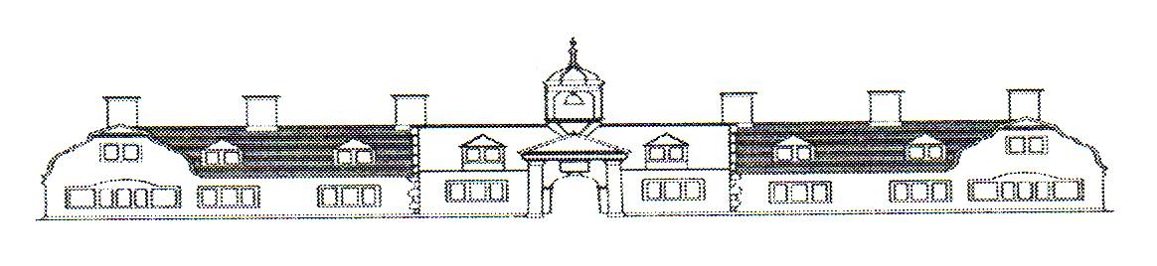
Llewellyn Almshouses are looking for a new Treasurer
Subheading: Are you a finance professional who could support a historic building that we manage in Neath?
Background
The Llewellyn Almshouses are a registered charity comprising of a Grade 2 listed building in Leonard Street, Neath which was built in 1897 and contains 9 bedsit units plus a 1-bedroom flat.
The operation of the Almshouses is governed by a Trust Deed and in accordance with the Trust Deed, the Almshouses are run by a board of five Trustees. Three Trustees are appointed by Neath Port Talbot CBC; the fourth Trustee is the Rector of Neath; and the fifth Trustee is co-opted by the Trustees. The charity does not have any employees and day to day management has been delegated to Tai Tarian and is carried out in accordance with a Management Agreement for which an annual charge is made. Tai Tarian also maintain the building.
In accordance with the Trust Deed, residents (technically Alms ladies) must be single women aged 45 or over.
The residents are charged a weekly contribution plus separate weekly charges for water rates and for heating and lighting.
The Almshouses are a Grade 2 listed building, and a five yearly inspection of the building is carried out by the Trustees’ architects, Alwyn Jones Architects, who specialise in the conservation of historic buildings. A report is prepared for the Trustees with recommendations as to any work which needs to be carried out. This generally results in the architects being commissioned to prepare and oversee the project to implement their recommendations.
A grant of up to £4k towards a project is normally available from Neath Port Talbot CBC. Historically, grants have also been received from CADW, but their current criteria make further grant aid unlikely.
A scheme to carry out timber repairs and improvements to paths and access areas is currently being prepared by the Trustees’ architects and is likely to be in the order of £60k (before grant aid).
Overview of Llewellyn Almshouses Finances
- Budgeted Income 2024/25: £45k

- Budgeted Expenditure 2024/25: £45k
(which includes contributions to extraordinary repairs and cyclical maintenance funds of £13k)

- Reserve Balances at 31st March, 2023:
- revenue reserve: £46k
- extraordinary repairs fund (ERF): £40k
- cyclical maintenance fund (CMF): £43k

- Value of investments at 31st March, 2023: £113.5k

- All financial transactions are recorded in the Tai Tarian’s ledger system, although the Almshouses do maintain a separate bank account.

- As part of the management agreement, the draft annual financial statements are prepared by Tai Tarian for approval by the Treasurer to the Trustees before being submitted for independent examination. The financial statements for 2022/23 can be viewed on the Charity Commission website.

- Due to the low level of income and expenditure, the financial statements are subject to an independent examination rather than a full audit.
The current Treasurer is looking to retire in June 2024 therefore the Trustees are now looking to appoint a new Treasurer to support the charity into the future.

Role Profile

- To provide financial advice to the Trustees to enable them to carry out their duty to manage the resources of the charity responsibly.
- To attend all Trustees meetings (generally 4 meetings a year) which may be held at the Almshouses or via Microsoft Teams.
- To prepare the annual budget, and as part of the budget setting process to review the level of reserves.
- To draw up and keep under review finance related policies (e.g. investments policy; reserves policy etc).
- To prepare grant applications for capital schemes.
- To authorise payment of invoices.
- Input into preparing the financial statements, including analysis of housing repairs to identify items to be charged to the ERF and CMF; income from and valuation of investments; reviewing the statements before submission for independent examination; answering queries arising from the independent examination; reporting to the Trustees.
- To liaise with the Trustees’ architects and to prepare reports on schemes of work recommended by the architects.

Is this role for me?
To succeed in this role, I must demonstrate

Strong financial skills | Ability to analyse data
Attention to detail | The ability to work well under pressure and have effective problem-solving skills
Excellent communication and leadership skills | Strategic thinking, integrity, and commitment

To be considered for this role I must demonstrate (skills/knowledge and experience)
Must be able to demonstrate skills in financial management. | Have knowledge of accounting principles, financial regulations, and investment strategies.
Experience in financial analysis, cash flow management and treasury operations.

Hours and working conditions
Time Commitment | Generally, 4 meetings a year, preparation time will be required  These meetings are based at Almshouses or via Microsoft Teams  Preparation of budget – annual  Input into / review of financial statements – annual  Grant applications and grant claims – generally once in a five-year cycle.  The position is voluntary.

To apply for the role
Please send your CV and cover letter via email to workingwithus@taitarian.co.uk, with the email subject Almshouses Treasurer role. The closing date is Monday 29th April.
If you would like to discuss the role further before applying, please contact Martin Jones, the current Treasurer on 07715 619523 or by email martin.jones51@btinternet.com.

