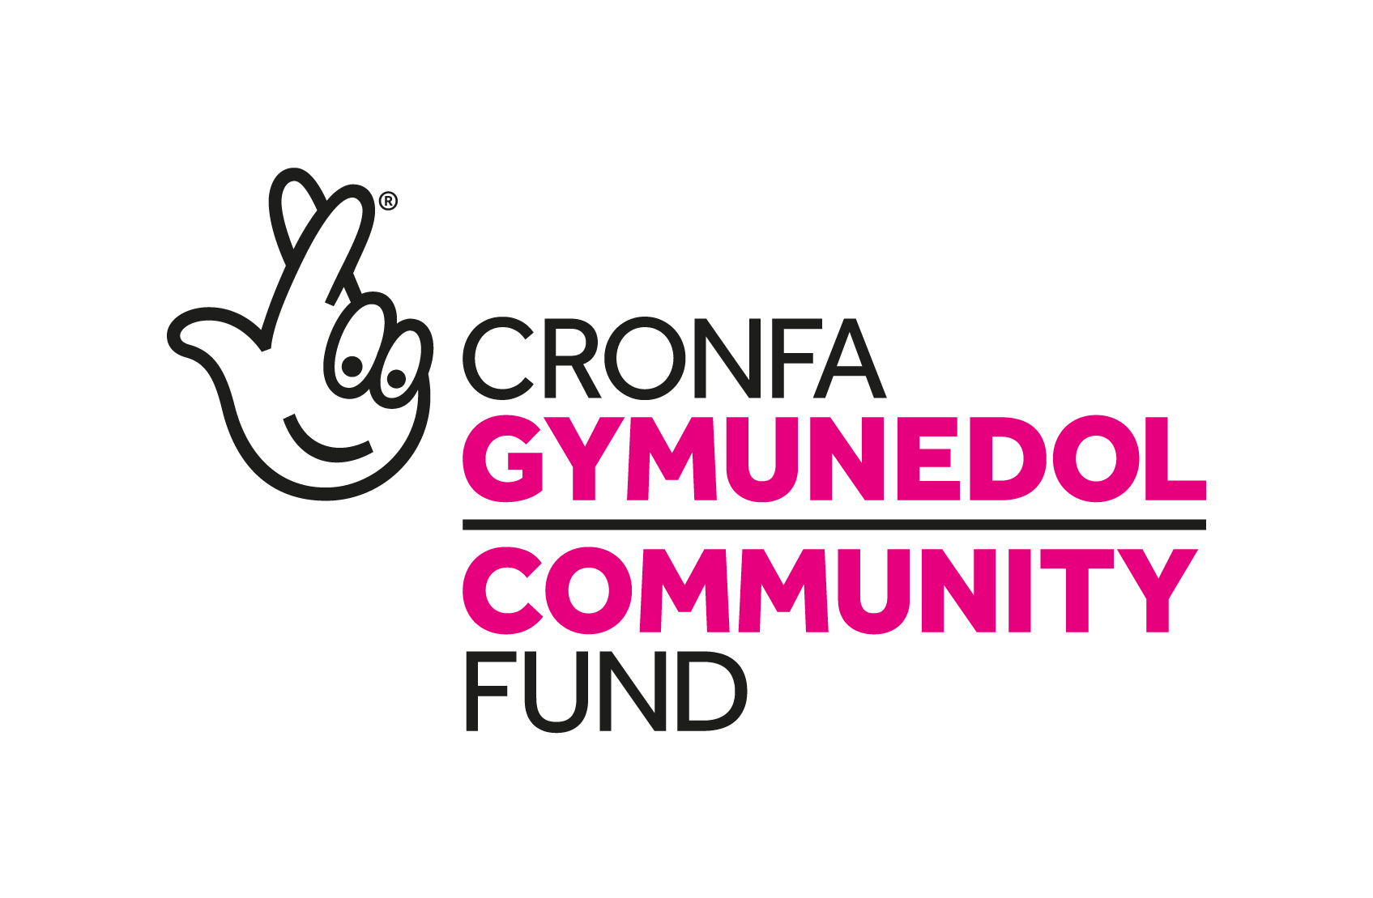
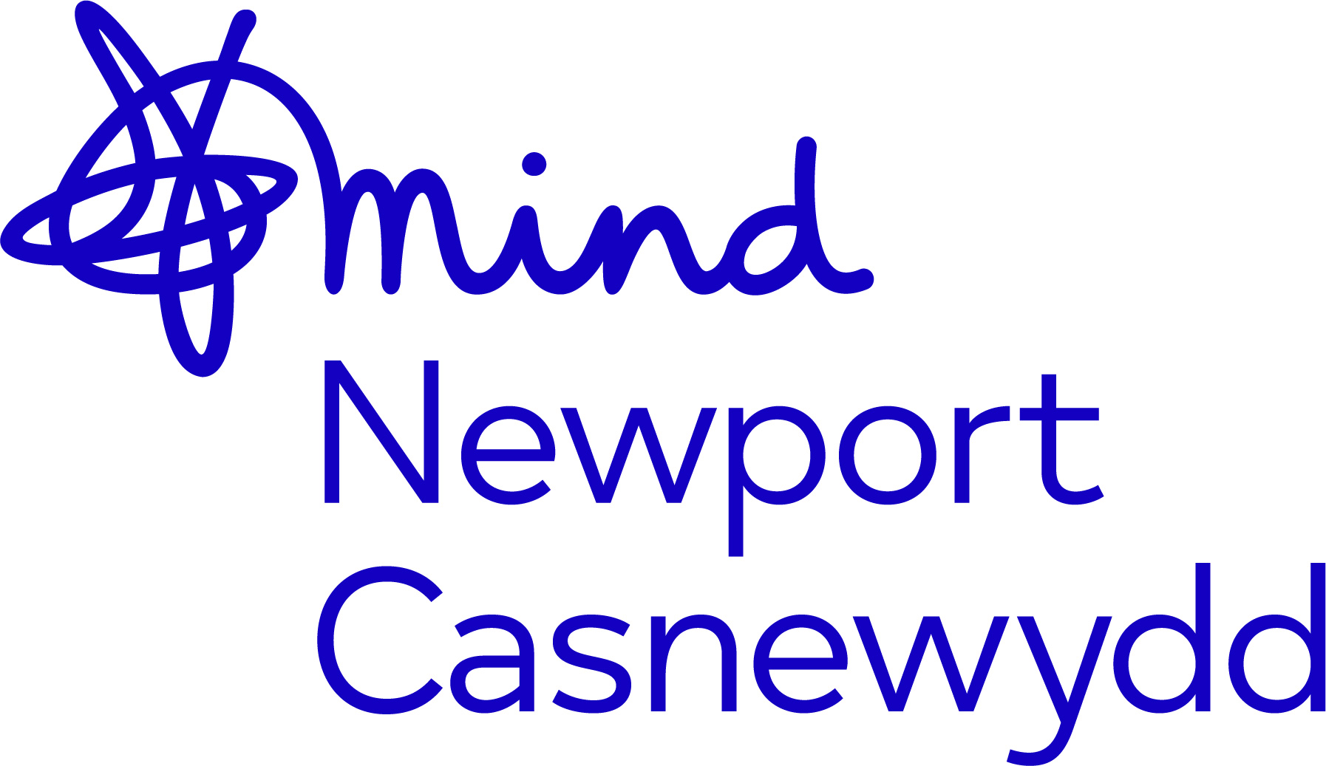

NEWPORT MIND
JOB DESCRIPTION

TITLE: | Mind Our Future Gwent Project Officer
RESPONSIBLE TO: | CYPF Service Manager, Newport Mind
GRADE: | NJC 15 – 23 £23953 - £28226
HOURS: | 1 x FT 37 hours per week  1 x PT 18.5 hours per week (0.5 FTE)
CONTRACT: | Fixed Term to September 2027(subject to continuation funding)

PURPOSE OF POST:
This is an exciting opportunity to work hand-in-hand with lead delivery partner ProMo Cymru, our project partners and young people over a period of 5 years, on a brand new National Lottery-funded Mind our Future Gwent project.
We will be designing new approaches for the prevention and early intervention of mental health problems in young people living in Gwent.
Placing young people at the centre of influencing and delivering meaningful change to child and young person-focused mental health services in Gwent, you will work in partnership with a wide range of stakeholders including young people, ProMo Cymru, Local Minds in Gwent and Gwent Youth Services throughout the lifetime of the project.
This role is part community based (face to face) delivery and part work from home, with flexibility.
PRINCIPAL RESPONSIBILITIES:
To assist with the implementation and day to day running of the Mind our Future Gwent project.

- Work in line with the core principles of the project:

- Co-production
- Universal provision
- Equality and Inclusion
- Building on Community Assets
- Learning
- Communication
- Sustainability
- Young Person- Centred design

- Work alongside young peer designers, recruited to co-produce the project in the delivery phase and hold governance over the project throughout its lifetime.

- Work within the community to engage young people in the project, to inform its development and shape the service design process.

- Fully co-produce the project, working closely with the Youth Engagement Volunteers and Wellbeing Ambassadors (young volunteers) at Newport Mind, young men and young people from deprived, BAME and LGBTQ+ communities of Gwent.

- Make every effort to include diverse young people in the research and co-production of the project and offer pathways to continued involvement for these young people.

- Work with the partners within the core principles of the project to achieve goals and outcomes identified during the development phase.

- Support the Project Manager, based with ProMo Cymru to produce project reports, schedules, budgets, reports invoices and action plans.

- Work with the Local Minds in Gwent to share expertise and knowledge of mental health and services for children and young people in each respective area.

- Engage with the local Youth Services to create successful engagement pathways for all young people and for dissemination of learning from the project.

EXPECTATIONS
- To work in line with, and to support the delivery of, the vision, mission, values and goals of Newport Mind and to be a champion for Newport Mind at all times.

- Adhere to and work within all the policies of Newport Mind, such as child protection policy, protection of vulnerable adults, confidentiality and data protection policies, and the policies contained within the employee handbook.

- To actively participate, engage with, and respond to, the Newport Mind supervision and appraisal processes.

- To attend and positively contribute to Newport Mind meetings and other meetings as required.

- To attend and positively contribute to Newport Mind training as required.

- To actively contribute to a positive, supportive and constructive working ethos, relationships and environment with Newport Mind, partner organisations and other organisations.

- To contribute to making Newport Mind a greener workplace.

- To support and contribute to our overall aim of the participation people with experience of mental health problems, including within Newport Mind and to be committed to working alongside people with experience of mental health problems, as colleagues, (paid & unpaid) experts and campaigners.

- To be flexible, adaptable and undertake work to support the aims of Newport Mind as required.

Disclosure and Barring Service Check
Because of the nature of this job, it will be necessary for the appropriate level of criminal record disclosure to be undertaken. Therefore, it is essential in making your application you disclose whether you have any pending charges, convictions, bind-overs or cautions and, if so, for which offences. This post will be exempt from the provisions of Section 4 (2) of the Rehabilitation of Offenders 1974 (Exemptions) (Amendments) Order 1986. Therefore, applicants are not entitled to withhold information about convictions which for other purposes are ‘spent’ under the provision of the Act, and, in the event of employment being taken up, any failure to disclose such convictions will result in dismissal or disciplinary action. The fact that a pending charge, conviction, bind-over or caution has been recorded against you will not necessarily debar you from consideration for this appointment.

PERSON SPECIFICATION
This acts as selection criteria and gives an outline of the types of person and the characteristics required to do the job, each point should be addressed in your application form. The second column indicates whether the characteristic is essential (E) or desirable (D).
Experience
- Experience of working with young people and communities  - Experience or a passion for exploring new approaches to existing problems, and challenging traditional approaches and structures  - Experience of providing wellbeing and practical support to young people to enable them to make the most of the opportunities that they are accessing.  - Direct or indirect experience of mental health problems. | E  E  D  D
Skills/Abilities
- Able to involve people and community groups in activities in creative and engaging ways  - Able to address barriers that prevent people from becoming involved in research and activities  - Able to work alongside young people especially young men and young people from deprived, BAME and LGBTQ+ communities of Gwent in a way that promotes their rights, dignity and independence.  - Able to communicate effectively to a high standard, and adjust communication styles to suit various audiences  - Able to work independently and as part of a number of teams and partnerships. | E  E  E  E  E
Equality and Diversity
- Able to understand and respond to the impact that disadvantage, inequality, stigma and discrimination have on individuals, communities and groups.  - A commitment to working alongside people with mental health problems or experience of mental health problems as colleagues. | E  E
Education and Training
- A relevant degree or relevant experience suitable to the role.  - Youth work qualification | E  D
Other Requirements
- A commitment to acquiring the skills, knowledge and understanding, through training and other opportunities, to become an expert in systems change work and mental health.  - Willingness to be flexible in meeting the needs of people with mental health problems, the needs of Newport Mind and the needs of other stakeholders as appropriate to the role.  - A commitment to the ethos and values of Mind and Newport Mind.  - A clean driving licence and access to a roadworthy car  - Ability to speak welsh | E  E  E  E  D
We will consider any reasonable adjustments under the terms of the Equalities and Human Rights Act, to enable an applicant with a disability (as defined under the Act) to meet the requirements of the post and to attend an interview.
The Job-holder will ensure that Newport Mind's policies are reflected in all aspects of his/her work, in particular those relating to;
- Child Protection and the Protection of Vulnerable Adults
- Equalities and Human Rights
(ii) Health and Safety
(iii) Data Protection

