Job Information Pack
Parish & Digital Fundraising Officer
We are the Catholic Archdiocese of Cardiff. Our mission is to support people, schools and parishes ensuring a vibrant Catholic Church now and in the future.

The Archdiocese of Cardiff was founded in 1916 and is one of three dioceses in the ecclesiastical province of Cardiff. The organisation is led by the Archbishop of Cardiff supported by a board of Trustees. The managerial team – the curia – undertake much of the administrative work within the diocese.

The charity has a key role supporting the most disadvantaged and vulnerable of all faiths and none. Each parish undertakes outreach activity including supporting older adults, running homelessness shelters, housing refugees and asylum seekers, alongside other social and educational activities. The charity is also custodian of cultural and artistic heritage of national significance, including 36 listed buildings, 25 of which are listed places of worship.

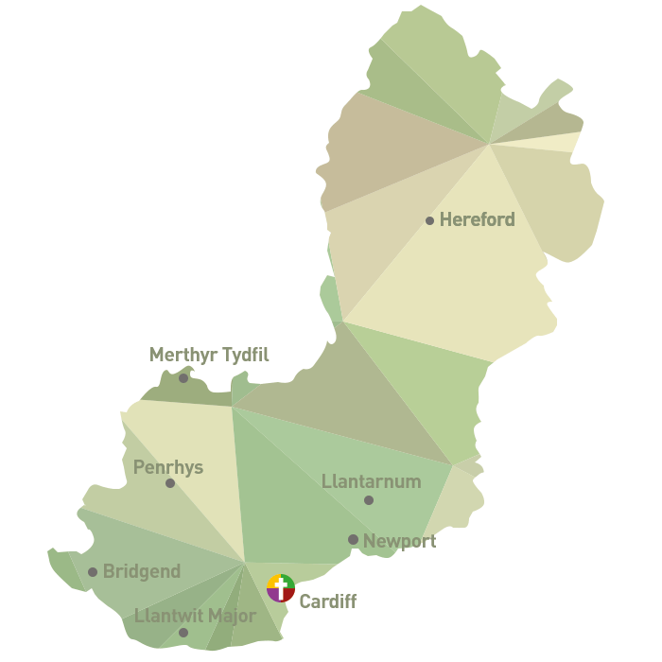
What we do

The Archdiocese covers 1,183 square miles, an area with a growing population of 1.6 million inhabitants. The diocese serves a worshiping congregation of approximately 14,000 people through a network of 63 parishes and 19,500 pupils in 54 Primary and Secondary Schools.

Incredible work is done by our team of parish priests and volunteers in communities across the diocese. Their dedication ensures that the church continues to help those in need guided by the principles of Christian charity.

Where we do it

The charity spans two areas with different devolved powers and languages. In Wales it extends from Dowlais in the north to Porthcawl in the west, in England, from Leominster in the north to Bromyard in the east.
The diocese covers all or part of eleven local authorities comprising Cardiff, Bridgend, Caerphilly, the Vale of Glamorgan, Rhondda Cynon Taff, Merthyr Tydfil, Blaenau Gwent, Torfaen, Newport, Monmouthshire and Herefordshire.
Context
The Archdiocese of Cardiff has been awarded grant funding from the National Lottery Heritage Fund and the Welsh Council for Voluntary Action (WCVA). You will be working in the Development Department to improve the resilience of places of worship across the Archdiocese of Cardiff. We want to develop our existing funding streams alongside identifying new opportunities to support vibrant churches which are engaged in our communities.

We are looking for enthusiastic and dedicated people to join our team – and we would like you to apply!

JOB TITLE: Parish and Digital Fundraising Officer (fulltime fixed-term contract for 12 months; possibility of extension)

LOCATION: Within the development Team, Archbishops House, 41/43 Cathedral Road, Cardiff, CF11 9HD. Hybrid working available, this role includes frequent travel across the diocese.

ACCOUNTABLE TO: Development Manager

RESPONSIBLE FOR: None

KEY RELATIONSHIPS: The Parish and Digital Fundraising Officer will work with the Development Manager, curia team, clergy and congregations.

JOB SUMMARY: The postholder will develop and implement systems to improve levels of charitable giving across the diocese. The Parish and Digital Fundraising Officer is responsible for managing the administration and processes involved in parish fundraising activity (esp. regular / planned giving). The role will also promote digital fundraising including contactless giving and online donations via websites and social media.
PRINCIPAL DUTIES AND RESPONSIBILITIES: The following duties are not an exhaustive list but are an indication of the responsibilities of the postholder:

JOB SPECIFICATION:

Planned Giving Drives (PGDs)
- Working with the Development Manager, implement the introduction of PGDs across the diocese to enable parishes to organise and support regular giving. This is likely to include:
  - Liaising with and learning from other dioceses that have already adopted PGDs;
  - Developing pilot PGs and roll-out plan;
  - Working with pilot parishes to introduce PGDs and learning from their experience;
  - Developing systems and processes to enable the efficient and timely roll out of PGDs across the diocese; and
  - Undertaking periodic reviews and taking appropriate action to ensure the approach taken is effective
- Advise and train parish priests and parish officers/ volunteers in the effective management of all aspects of stewardship and financial sustainability.
- Alongside the Development Manager, help build, manage and maintain a pipeline of PGDs with 20 to 25 parishes each year.
- Help to define and deliver a toolkit of resources both online and hard copy to support parishes to become more financially sustainable.
- Assist in workshops and training at a parish and deanery level to equip volunteers and staff to:
  - Deliver effective PGDs/ stewardship campaigns;
  - Develop key messages to encourage greater generosity; and
  - Better understand giving, funding, governance and budgeting, in order to manage and maximise their resources.
- Prepare financial information for parishes ahead of PGDs
- Signpost clergy and parishes to funding sources for specific projects, including working closely with colleagues across other departments to ensure that advice is up-to-date and relevant.
- Create and update template materials to support a parish to hold a planned giving drive, including financial data and stories from the parish
- Build, maintain and manage relationships with parish priests and finance committee members, to discuss their parish’s financial picture and schedule site meeting(s) with them
- Maintain detailed notes on parish contact, helping to build a record of fundraising activity, messages and themes used, how local volunteers helped, etc., with the aim of supporting the Development Manager to continuously improve service provision;
- Prepare speaker notes, newsletter inserts, instructions for volunteers, pledge cards/forms, and other materials (prepare drafts, offer to the parish, make revisions, finalise);
- Prepare thank you letters and other materials as required;
- Ensure the correct quantities of materials are produced on schedule for use by the parish;
- Arrange delivery of materials and supplies to the parish;
- Brief, train, coach and prepare parish priest and all volunteers in required tasks and activities;
- Liaise with parish staff and volunteers to quantify returns and monitor progress, prepare reports and implement follow-up procedures;
- Record and analyse data from PGDs, to continuously improve template materials for parishes;
Digital / Contactless Giving
- Oversee the rollout of contactless giving devices across the diocese, maintaining excellent knowledge of current providers and technology, keeping up to date with advances in the area of digital giving
- Encourage parishes to take up contactless giving devices, keeping up to date with performance of parishes already using contactless giving devices.
- Regularly update and report on income and analyse data to improve performance
- Support parishes and other diocesan projects to maximise the use of contactless donation devices, liaising with suppliers to place orders, visiting parishes to help with installation;
- Maintain excellent relationships with suppliers, ensuring ongoing negotiation on rates and that parishes receive excellent customer service
- Produce promotional materials, such as posters and flyers, to help increase adoption of contactless giving;
- Prepare instructions to support parishes to understand setting up and using their device.

Online Giving / Social Media
- Encourage parishes to adopt and engage with online donation pages and functionality
- Support parishes to understand new ways for parishioners to give online
- Work with parishes and Development Manager to create adverts for paid social media, helping to make decisions to improve performance of appeals based on data from Facebook analytics

Networking
- Together with senior staff, develop relationships with new and current funders and partner organisations ensuring they are motivated to collaborate with the charity
- Explore and develop the potential for private and business sponsorship
- Develop relationships with local public sector partners to maximise funding
- Raise awareness of the charity through local networking and utilising local media channels
Building Resilience Project
- Alongside the Building Resilience Project Manager and Development Manager, support four listed churches with grant applications to achieve the ambitions of pre-prepared business plans.
- Create and develop strategies to grow parish income (which could include lettings, co-production or social enterprise)
- Build capacity of clergy and congregations in terms of sustainable fundraising
- Providing tailored support and training to clergy and congregations seeking funding including developing grassroots fundraising campaigns.
- Work with others to maximise opportunities to generate donations and sponsorship

Other
- Create a culture of innovation and best practice in fundraising, supported by the work of the Development Manager
- Administer email communication activity, using Mailchimp (or equivalent)
- Help the Development Team with events, annual appeals and the creation of stewardship-based newsletters and communications to donors and parishes;
- Undertake other parish-related and wider fundraising assignments as determined by the Development Manager.
- Build excellent relationships with colleagues across the organisation.

Skills/competence requirements | Essential/ Desirable | Assessed
A strong team player who is confident, reliable, creative, self-motivated and target driven | E | Application
Clear and persuasive verbal skills with ability to sell concepts | E | Application
Strong work ethic and personal flexibility in order to get the job done and meet deadlines | E | Application
High degree of accountability and a “can-do” attitude | E | Application
Solid organisational and time management skills; able to work independently | E | Application
Keen sense of discretion and tact, comfortable handling confidential information | E | Application
Excellent interpersonal skills with ability to develop strong relationships with donors and volunteers | E | Application
Ability to persist and find innovative solutions when faced with scepticism regarding new ways of working | E | Application
Ability to attend frequent out-of-office meetings and events, and to work select evenings or occasional weekend days – TOIL (time off in lieu) to be taken for evening or weekend hours worked | E | Application
Experience interpreting and presenting basic financial data alongside identifying trends | D | Application
Brochure/leaflet/website design skills, creative writing and image use | D | Application
An understanding of Gift Aid and tax efficient planned giving as well as raising funds from trusts and foundations. | D | Application
Knowledge and a practical understanding of the relevant legislation and regulations relating to charity fundraising, including data protection | D | Application
Awareness of and appreciation for the Catholic Church and its teachings | D | Interview
Public speaking skills | D | Interview
Experience
Fundraising experience in a non-profit setting, or strong transferrable skills | E | Application
Experience with technology such as websites, mobile devices etc., and an ability to explain their use to others | E | Application
Familiarity with or willingness to learn the use of database packages | D | Application
Prior experience in a parish setting with familiarity of clergy roles and those of parish staff and the use of volunteers | D | Interview
Prior experience in a Christian Stewardship role | D | Interview
Qualifications
Proficiency in Microsoft Office – especially Outlook, Word, Excel, PowerPoint, Microsoft Teams, Zoom – and cloud-based applications | E | Application
Full driving licence (category B) | E | Application

GENERAL CONDITIONS:

Diversity: We understand the benefits of employing individuals from a range of backgrounds, with diverse cultures and talents. We aim to create a workforce that:
- values difference in others and respects the dignity and worth of each individual
- reflects the diversity of the nation that the Catholic Church exists to serve
- fosters a climate of creativity, tolerance and diversity that will help all staff to develop to their full potential.

We are committed to being an equal opportunities employer and ensuring that all employees, job applicants and other persons with whom we deal are treated fairly and are not subjected to discrimination. We want to ensure that we not only observe the relevant legislation but also do whatever is necessary to provide genuine equality of opportunity. We expect all of our employees to be treated and to treat others with respect. Our aim is to provide a working environment free from harassment, intimidation, or discrimination in any form which may affect the dignity of the individual.

Standards of Behaviour and Conduct: Staff are expected to act at all times with due consideration for others and in a manner befitting their position as employees of the Church and as professionals, whatever their job.

Safeguarding: Staff are expected to understand what is meant by safeguarding vulnerable groups (children, young people and adults) and how to raise concerns.

Health and Safety Responsibilities: The Archdiocese takes Health and Safety at work very seriously and requires staff to familiarise themselves with, and follow, these policies.

Confidentiality: Staff must not pass on to unauthorised persons, any information obtained in the course of their duties without the permission of their Head of Department.

Data Protection: If you have contact with computerised data systems, you are required to process and/or use information held on a computer in a fair and lawful way. You are also required to hold data only for the specific registered purpose and not to use or disclose it in any way incompatible with such purposes.

TERMS OF EMPLOYMENT:

Starting Salary: Salary starts at £30,000 per annum.

Hours of Duty: Normal hours of work are 35 hours per week, Monday to Friday with an hour’s unpaid break for lunch. Out-of-office meetings and events, alongside select evenings or occasional weekend working is to be expected. TOIL (time off in lieu) to be taken for evening or weekend hours worked. Requests for flexible hours will be considered.

Expenses: An office pool car is available for staff use. Personal car users will be reimbursed at 45p per mile and all out of pocket expenses incurred will be reimbursed subject to satisfactory accounting.

Annual Leave: 30 days paid leave per year. This is exclusive of public holidays and additional holidays approved by your employer.

Contract: The post is being part-funded by the Archdiocese of Cardiff, the National Lottery Heritage Fund and Welsh Council for Voluntary Action. The post is offered initially on a 12-month fixed-term contract, subject to a six-month probationary period. If targets are met consideration will be given to contract extension.
Notice period: There will be an initial probationary period of six months following which an appraisal will be made. If successful, a notice period of 1 month from either side will be required.
References: Should a job offer be made the Archdiocese of Cardiff will require the names and addresses of two references, including a recent employer. All references will be treated in the strictest confidence.

Equality Monitoring Form: Please note, we will need you to submit the Equality Monitoring Form before we can process your application.

Applying: Please return an Application Form and Equality Monitoring Form to hr@rcadc.org (to request these forms please contact the Archdiocese of Cardiff at hr@rcadc.org)

Interviews: Interviews will provisionally take place on the week commencing 27th June 2022.

