Housing Officer
£20,500 - £21,754
37.5 hours, permanent

Job description
Thrive Women’s Aid is an established and well-respected organisation that makes a genuine difference by delivering support services to families impacted by domestic abuse. We consider ourselves to be a progressive and dynamic organisation that is at the forefront of our sector.
Thrive is a friendly, supportive and rewarding place to work. We know that our employees are key to our organisation’s success and growth which is why we value our employees and offer support, training, development and progression to enable everyone to reach their full potential. We also offer comprehensive, flexible and agile working practices.
We are seeking a new Housing Officer to join our expanding Residential Services Team. The role requires a good understanding of social housing and property/tenancy management. Knowledge or experience of domestic abuse is desirable but not essential – we’ll provide you with relevant training in this area.
As part of the role, you will have the responsibility of overseeing approximately 15 units of accommodation. You will take a leading role in planned and reactive repairs and maintenance of Thrive properties. You will also provide high-quality tenancy management support including; assessment of eligibility, onboarding of new tenants and ongoing support to enable tenancy sustainment.
Recording accurate data will be key and ensuring that comprehensive records of activities of the service are uploaded to our data management systems.
What would you need to be successful?
- A motivated team player
- An ability to build rapport and develop effective professional relationships
- An organised person who can manage workload effectively
- Someone who ensures high quality and integrity within their work

Your track record will include the experience in delivering tenancy related support.
Benefits
- A pension scheme is provided, with a 6% employer contribution
- Annual leave entitlement starts at 25 days (pro rata), with an additional day for each year’s completed service (to a maximum of 31 days)
- Comprehensive Flexible Working Policy
- A clear pay framework with yearly incremental rises
- Organisational sick pay and ½ days leave for every 6 months no sickness absence

Things you need to know
- A disclosure and barring security check is required for this role.
- Successful candidates will be based at Thrive Head office and will be required to work from home and various locations in the community

Working for Thrive
Vision
Our Vision is to create safe communities, free from domestic abuse where people and families can flourish and build successful independent lives.
Mission
To be an innovative and sustainable provider of excellent, good value domestic abuse services that drive prevention, provide interventions and enable progression.
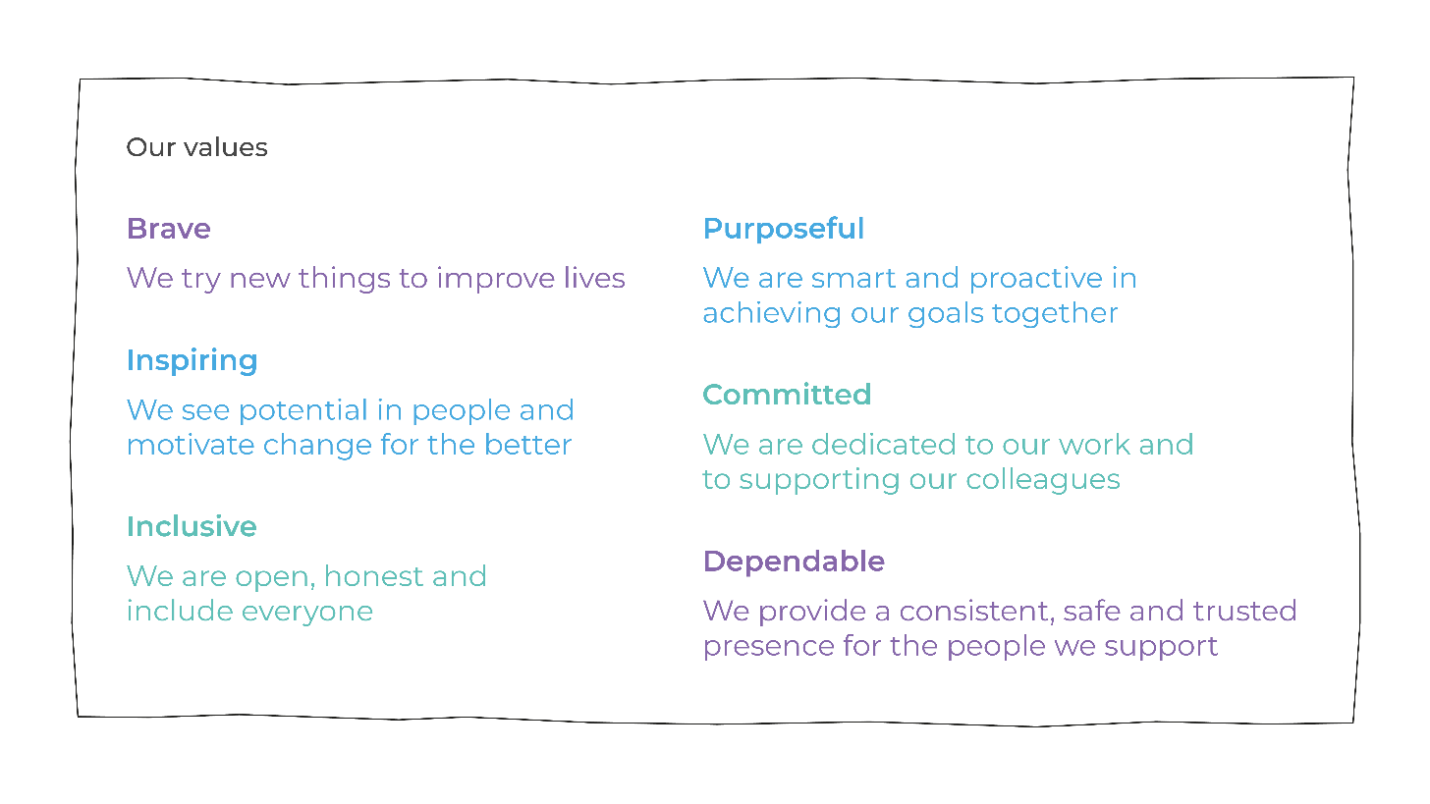
Please click to view our Impact Report and Strategic Plan.

Apply and further information
To apply: Please complete an application form, noting the deadline below.
Contact point for applications: Kate Purchase / katep@thrivewa.org.uk / 01639 894 864
Closing date: 29th August 2022 5pm
Interviews: Friday 2nd September 2022

  - Job Profile
Job Title | Housing Officer (Residential Services)
Grade / Salary | £20,500-£21,754
Hours | 37.5hrs
Reporting to | Residential Services and Estates Manager

Job Purpose
To work as part of the Residential Services Team to provide comprehensive housing and tenancy management services, including the management of rent and service charge payments, liaising with Registered Social Landlords and contractors on property maintenance issues, supporting and promoting tenancy sustainment and reporting on voids and lettings.

Key accountabilities
1 | Undertake planned housing management tasks relating to Fire, Health and Safety regulations and legislation.
2 | Assist the Residential Services team to identify, report and monitor repairs and maintenance issues across all Thrive Supported Accommodation projects. Take a leading role in liaising with Registered Social Landlords and contractors to resolve issues promptly.
3 | Develop and maintain a live framework of suitable contractors to undertake repairs and maintenance within Thrive properties.
4 | Support the Residential Services and Estates Manager with the acquisition of properties, void management, and lettings.
5 | Assess the suitability and eligibility of applicants for Thrive properties and support the sign-up process of new contract holders (tenants).
6 | Support contract holders (tenants) to source furniture for their property through grant applications.
7 | Refer women (internally and externally) for specialist support; maintain collaborative working relationships with all Thrive WA staff and partners.
8 | Provide information, advice and guidance to contract holders (tenants) to support tenancy sustainment.
9 | Ensure that contract holders (tenants) understand their rights and responsibilities as set out in the terms of their agreement with Thrive and Registered Social Landlords.
10 | Support the Residential Services and Estates Manager to address housing management issues including breaches of contract and anti-social behaviour.
11 | Where necessary to assist in taking legal action to enforce the conditions of the contract such as non-payment of rent, damage to property and evictions.
12 | Keep appropriate records utilising the organisation’s electronic database, in line with Data Protection policies, laws and regulation.
13 | Attend regular supervision internal and external sessions, team meetings and engage in continuous professional development.

Line Management Responsibilities | N

Qualifications and Training
Desired | Domestic Abuse Qualification (Group 2 of the National Training Framework)
 | Housing management / property related qualification
Essential | GCSE or Level equivalent

  - Person Specification
Criteria | Essential | Desired
Education and Qualifications | Knowledge of social housing and property/tenancy management  Minimum education (GCSE or Level 3 equivalent). | Awareness or training in Domestic Abuse
Experience | Experience in supporting tenancy sustainment, evidencing empowerment and promoting independence  Experience in addressing Housing Management issues and working with tenants and landlords to report and resolve issues | Working with individuals who have multiple or complex needs
Knowledge, skills  and abilities | Knowledge of the barriers faced by women experiencing domestic abuse and other forms of vulnerabilities when accessing housing  A professional approach, with an ability to maintain appropriate boundaries with tenants | Knowledge of one or more of the following areas:-  Welfare rights and benefits  Legal issues  Safeguarding
Personal attributes | Ability to work collaboratively as part of a team  Excellent communication and interpersonal skills  Ability to prioritise workload effectively  Commitment and desire to learn and develop own skills | Experience using Oasis DA and/or other housing and support database systems
Other | Driving Licence and use of own car with business insurance  Commitment to the principles, aims and objectives of Women’s Aid  Ability to work flexibly and comply with Thrive’s lone-working policy. | Ability to speak Welsh  Ability to speak ethnic language

