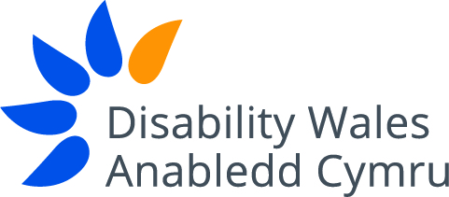

Equal Opportunities Monitoring Form

Disability Wales (DW) is committed to Equal Opportunities and is fully aware of legislation surrounding this. DW wishes to reassure applicants that this form will not be used at any stage of the recruitment process and will be separated from the application form immediately on its receipt. Any information given on this form will remain confidential and only be used for monitoring purposes to assess the effectiveness of our equal opportunities policy.

Surname: ...............………..........................First Name(s)......……....................................

Post applied for: .................................................................................................................

Where did you learn of this vacancy: …………………………………………………….........

Please tick the appropriate box:

Gender: Male Fe Female

Age: 16 -19 20 -29 30 -39 40 -49 50 -59 60+

What is your ethnic group? :- (Please choose one)

White

British English Welsh Scottish Irish Other White

If other, please specify ………………………….

Mixed/Multiple Ethnic Group

White and Black Caribbean White and Black African

White and Asian Other Mixed

If other, please specify ………………………….

Asian/Asian British

Indian Pakistani Bangladeshi Chinese Other Asian

If other, please specify ……………..……….….

Black/African/Caribbean

Caribbean African Any Other Black

If other, please specify ………………………….

Other Ethnic Group

Arab Any Other Ethnic Group If other, please specify

Prefer not to say

The Employment Equality Regulation 2003 makes it unlawful to discriminate staff on grounds of their sexual orientation and their religion or similar belief. There is no legal requirement to obtain this information, but it is considered good practice. The purpose is to try and understand whether DW is attracting candidates from a representative selection of society and to improve understanding and needs of staff and to identify areas where adjustments or improvements may be made where possible in order to provide a better work/life balance.

Sexual orientation
How would you define your sexual orientation?

Lesbian Gay Bisexual Heterosexual Prefer not to say

Other If other, please specify ……………………………………..……….…

Religion or belief:
Please tick one box only; categories determined by the Office of National Statistics

Christian Buddhist Hindu

Jewish Muslim Sikh

Other No religion Prefer not to say

If other, please specify……………….…………………...............................................……

Disability

DW’s definition of 'disabled person' is one who on account of having a physical and/or sensory impairment, learning difficulty or mental health issue faces barriers due to attitudinal, societal and/or environmental factors.

Do you identify yourself as a disabled person? Yes No

Thank you

