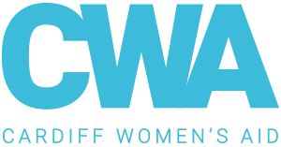

January 2020

Dear Applicant,

Re. Position of CYP Support Worker.

Thank you for the interest you have shown in the above post and in joining Cardiff Women’s Aid. For more information about our work please visit our website: www.cardiffwomensaid.org.uk. You can find out more about RISE by visiting: https://rise-cardiff.cymru/.

Please find enclosed an application pack which includes:

• Job description and person specification
• Application form
• Equal Opportunities form (anonymous)

Please return your completed application form and equal opportunities form via email to hr@cardiffwomensaid.org.uk, alternatively you can send it via post: 16 Moira Terrace, Cardiff, CF24 0EJ. Please complete the application by the closing date for this position – 12 noon, Monday 5th February 2021. Interviews will be held digitally.

Yours faithfully,

Amelia Baugh
HR Assistant

