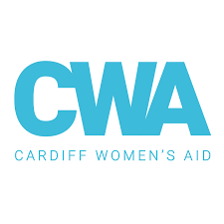
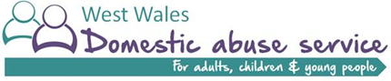
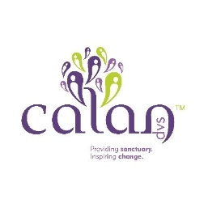
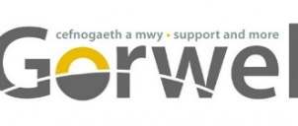
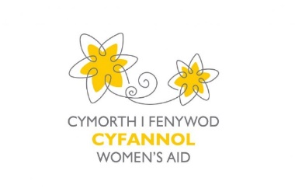

Job Description

Title |  | CYP Support Worker
Salary |  | Between £20,500 – £22,500 dependant on area
Location |  | Varied Location
Contract Type |  | 3 year FTC subject to funding
Hours |  | Full time equivalent will vary dependant on area, up to 37.5 hours per week (options to job share)
Working Pattern |  | Generally 9am to 5pm  All staff must work flexibly on occasions to meet the needs of women and children.  Some inclusion in on call systems may be required dependant on area.
Accountable to |  | Line Manager within each organisation, supported by Ar Trac Manager
Overview of Organisations  Calan  Cardiff Women’s Aid  Cyfannol Women’s Aid  Gorwel  West Wales Domestic Abuse Services |  | Our mission  Is for women and their children to flourish in a life free of domestic abuse and sexual violence.  Activities  The Organisations deliver a range of services within Wales that encompass prevention, awareness raising, safety, support and personal development opportunities for women, men and their children who have experienced domestic abuse and/or sexual violence. Please see each organisation website for particular services.
Overview of the Project |  | Ar Trac is an exciting new project for children and young people who have experienced or witnessed domestic abuse.  The project will deliver a tailored and individual pathway for children and young people that builds on their strengths.  Within each region 3 project workers will support and deliver the project in collaboration with other areas and with the support of a project manager, delivery team and young people.  The support offered, will include 1-2-1 mentoring (aged 5 to 11), 1-2-1 peer mentoring (aged 10 to 13), 1-2-1 support addressing adolescent to parent violence (aged 11 to 16), Group work that supports the child-parent bond (aged 7 to 11), Group work that addresses adolescent to parent violence and abuse (age 11 to 16), Gender specific group work that builds self-esteem, communication skills, and supports emotional regulation (age 11 to 16).  The project will work with academic partners to evaluate the project and with children and young people to develop and facilitate training resources to professionals.  The project will be delivered across Wales in partnership with the organisations below  Region County Delivery Partner  Gwent Newport Blaenau Gwent Cyfannol Women’s Aid  Cardiff and the Vale Cardiff Cardiff Women’s Aid  Cwm Taff Morgannwg RCT Cardiff Women’s Aid  West Glamorgan Neath Port Talbot Calan DVS  Powys South Powys Calan DVS  West Wales Ceredigion North Pembrokeshire West Wales DAS  North Wales Gwynedd Anglesey Gorwel
Purpose of the post |  | To provide specialist support to children and young people who are affected by Domestic Abuse and sexual violence and/or at risk of abusive relationships. Working within the Organisational and Supporting People Frameworks you will work towards enabling children and young people so that they are able to make positive changes to their lives in order to increase safety, well-being and to reduce the threats of homelessness.
Responsibilities |  | - To liaise with external agencies to identify children who may benefit from the project  - To engage with children, young people and their families, carry out initial assessments of risks, needs, strength, and collate relevant information from the child, parents, and other agencies where relevant.  - To develop a detailed support package for the child/young person, identifying goals, aspirations and needs.  - Facilitate group programmes, 1-2-1 mentoring and or support with children and young people between the ages of 5-16 who have experienced or witnessed domestic abuse as required.  - Work with families, children and young people in an empowering, solution focused and engaging manner.  - Support families in identifying and addressing issues relating to their children and support positive parenting, healthy relationships and welfare of children and young people.  - Develop local focus groups where children and young people can contribute to the development of the project.  - Work alongside young people in developing resources, group sessions and toolkits.  - Co-facilitate training for professionals with young people  - Recruitment and management of volunteers and peer mentors, undertaking the relevant checks and training to enable them to carry out their role.  - Prioritising and managing caseloads in line with packages of support and support plans  - Ensure accurate and timely records are maintained in relation to all aspects of the service and case work, including inputting information into our Information Management System.  - Support, signpost and refer women and children to the services they may wish to engage with for example social services, the police, parenting, health, legal, DWP, housing, homelessness, recreational, educational and cultural services and other internal services.  - To be fully aware of the child and adult safeguarding policy and procedures and report to line manager any concerns in this area.  - To advocate on behalf of children and young people and ensure that children feel safe, supported and listened to within our service and in dealings with other agencies.  - To participate in meetings encourage women and children to participate in and give feedback on service provision.  - Assist in qualitative and quantitative data collation.  - Promote the service in the local area.
Line Management:  General | - Provide line management to the volunteers working with children and young people including induction, supervision and annual appraisal.  - Recruit, support and mentor peer mentors  - Assist in identifying volunteer training and development needs.  - To demonstrate and promote the organisation’s ethos, vision and values.  - To represent the organisation at external meetings, public events, conferences and similar ensuring that the Organisation’s reputation is protected and enhanced.  - To actively work in partnership with other agencies and organisations to achieve better outcomes for women and children affected by Domestic Abuse.  - Participate in team meetings, supervision and appropriate training.  - To work within the Organisations Policies and Procedures and Code of Conduct.  - To Support families and children to participate and be involved in decision making and developmental processes and service delivery.  - Any other reasonable duties as required.  - It may be necessary, following consultation, to amend the job description in light of experience and changing circumstances.

Person Specification

Criteria | Essential | Desirable
Education and Qualifications | Minimum NVQ Level 3 or equivalent in a relevant field, i.e. youth and community work child or social care, health or education OR equivalent experience in a related discipline.  Welsh essential for Gorwel. | Qualification or training in child development.  Qualification or training in domestic abuse.
Experience | Significant experience of working with vulnerable children and/or young people who have experienced or witnessed domestic abuse.  Proven experience of liaising with statutory and voluntary agencies.  Experience of engaging families in needs assessment, risk assessment and safety planning.  Experience of working with and developing support activities including group work with children and young people.  Experience of delivering educational interventions to groups of children and/or young people.  Experience of working in partnership with and developing relationships with other agencies.  Experience of using IT / computer based systems on a daily basis.  Ability to engage families in solution-focussed problem solving.
Knowledge, understanding and skills | Sound knowledge and understanding of domestic abuse and its impact on children and young people.  Ability to work with women and children in crisis and in crisis situations  Understanding of child/young people protection issues  Knowledge and ability to work within the principles of facilitated self help  Ability to provide meaningful, practical and emotional support specifically to children and young people  Understanding of client confidentiality and how to maintain it  Good written and verbal communication skills  Ability to work effectively on own initiative and as part of a team  Good organisational skills and ability to prioritise own workload.  Administrative and file management skills and ability.  Strong organisational skills and ability to prioritise own workload.  Good administrative and IT skills  Comprehensive understanding of equal opportunities and anti-discriminatory practice.  Knowledge of legislation relating to Children Act 1989.  Knowledge of relevant legislation concerning children and young people. | Welsh written and verbal communication skills
Personal attributes | Able to demonstrate behaviours that accord with Cyfannol Women’s Aid “Essential 6” Qualities Framework:  - Empowering  - Integrity  - Self-Awareness  - Collaborative  - Resilient  - Dedicated
Other | A current valid driving licence, access to a car and insurance covering business use.

