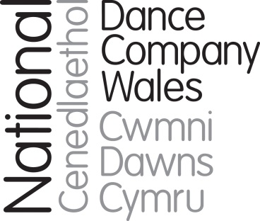

Brief for position of Tour and Projects Producer

August 2018

Marcos Morau’s Tundra, 2017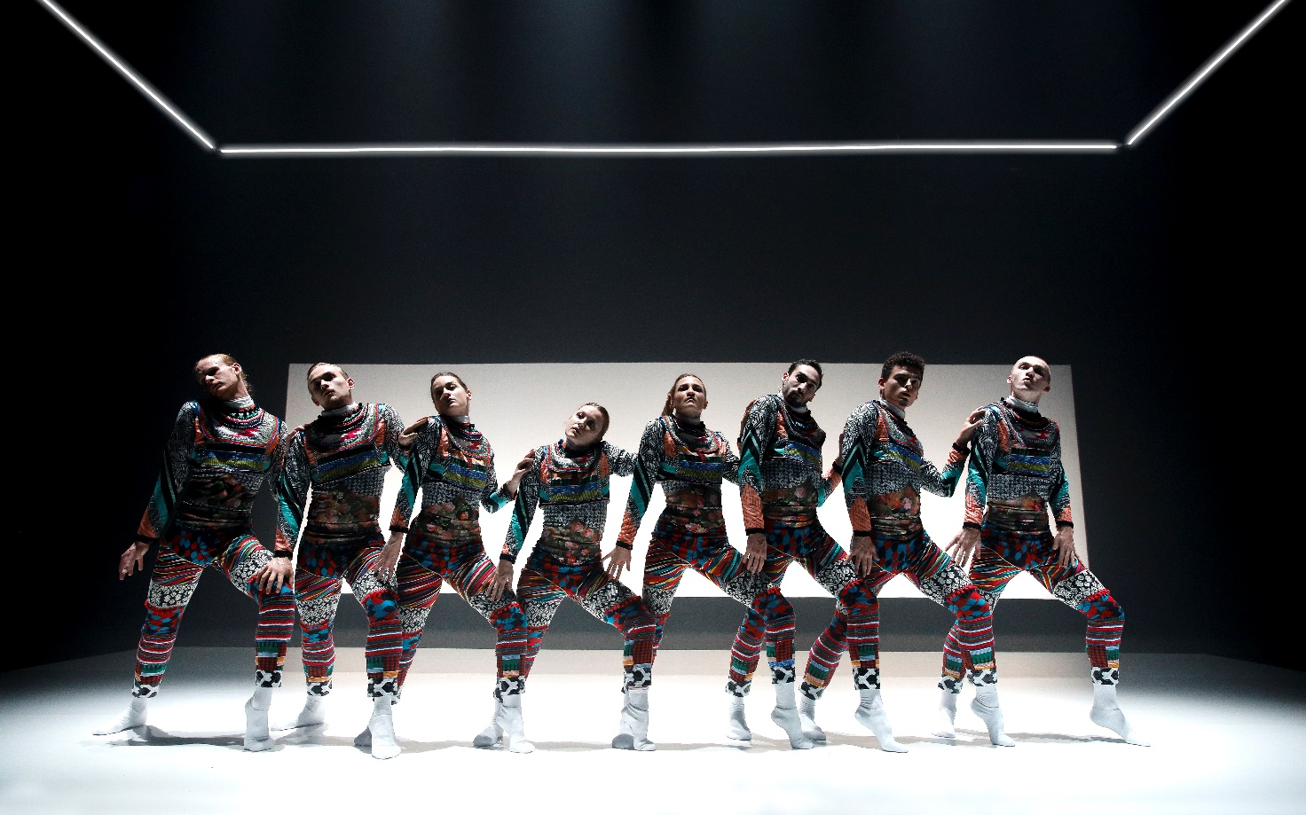

Background

NDCWales is one of the foremost national arts companies of Wales. It creates impact with work of the highest quality by working with exceptional UK and international choreographers, to reach and inspire audiences across Wales, the wider UK and around the world.

The Company is on a high after two years of extraordinary achievement which has raised its profile and enhanced its reach and reputation. 2017 saw the successful delivery of NDCWales’ most ambitious project to date – P.A.R.A.D.E. created with Marc Rees and a host of other artists to mark the centenary of the Russian Revolution. P.A.R.A.D.E was the icing on the cake of a year which has saw a surge in international profile with visits to Hong Kong, Germany (twice) and Austria. A regularly funded organisation of the Arts Council of Wales, the Company has successfully diversified its funding base to raise funds from trusts, individuals and corporate sources.

A new 3-year grant enabled delivery of a small-scale tour and associated participation work, and the Company is co-producing a contemporary dance opera in Autumn 2018. A new post of Learning-lead Dancer works with the rest of the dancers and others to deliver excellent participatory work with people of all ages across Wales, and the wider UK.

The Company was founded as ‘Diversions’ in 1983. The Company grew in size and stature, mounting tours to China, Australia, India and many European countries. In 2004 the Company moved to a new purpose-built home, Dance House/Tŷ Dawns, as part of the new Wales Millennium Centre (WMC) and in 2009 the Company became National Dance Company Wales, reflecting its status and its role in leading and championing dance in Wales.

2015 saw the start of a new phase in the Company’s history with a new Chief Executive (Paul Kaynes), and latterly a new Artistic Director (Fearghus Ó Conchúir). The Company’s role as an ambassador for dance in Wales is vital to its new strategy, increasing the reach of its international touring and forging contacts and gathering knowledge which it brings back to Wales for the benefit of the wider dance sector.

The Dance House is the Company’s home and hub, acting as a centre for the creation and rehearsal of the Company’s work, a training base for the Company’s dancers and other dance artists, a space for hire as a rehearsal, creation and performance space, a centre for community activity and youth dance, and as a wider resource for the arts sector in Wales.

The Company

The Company is based at The Dance House/Tŷ Dawns in Cardiff, at the Wales Millennium Centre, where it has a dedicated rehearsal studio and performance space. There is currently a company of eight dancers and two student apprentice dancers who perform at base and at other venues in Wales, the wider UK and overseas. Company members also deliver a range of education and participation projects.

NDCWales creates dance which engages and resonates with audiences by being extraordinary and inclusive, working with the best dancers and choreographers from across Wales and beyond to make dance for stages large and small, in unusual spaces, and online.

We perform across Wales, the UK and around the globe, taking people on journeys of discovery, creating opportunities to participate, discuss, watch and learn about dance, about themselves and about the world. Our status as the national dance company is a privilege that informs everything we do: how we make work, who we work with and where work is placed. It is important that our programmes resonate with the diverse communities of Wales. Working in collaboration, we will ignite the spark of interest in dance with the widest range of promoters in every corner of the nation, building larger, broader audiences for dance.

NDC Wales is part of the Arts Council of Wales (ACW) portfolio. ACW is the Company’s major funder, awarding a revenue grant of £834,186 for 2018/19.

The key strategic priorities for our current business plan are:
- Developing the artistic vision with the interests/aspirations of audiences at the heart of our work, alongside our brand renewal and new approach to audience engagement
- Become an ‘all-Wales’ company creating the highest quality work with and for any and every community in the nation, entailing moving from an exclusive focus on touring to theatres of 250-900 seats only, to one which includes a dynamic and versatile model of presenting work which enables major collaborations, outdoor, smaller and larger scale touring, site specific work and community projects in a calendar which maximises the impact and exposure of the dancing company
- Revolutionising the Company’s approach to participation and learning, creating a more varied programme of activity which inspires and engages the people of Wales with the power of dance
- Fulfilling our role as a leader of dance in Wales, acting as an exemplar for the sector, recognised outside Wales, and bringing its knowledge and contacts home to make meaningful connections and create imaginative partnerships
- Securing the Company’s future through robust financial and operational management, always seeking out more efficient and effective ways to deliver everything we do
- Investing in the resources needed to tap into new income streams to deliver long-term stability for the Company, including income from trusts and foundations, individual donors, space and asset hire and box office/touring fees.

Structure and Governance

NDCWales is a registered charity with trustees who also act as directors of the Company. The

Board of NDCWales has a number of suitably qualified members who have an excellent track record of attendance and willingness to share their expertise and given their time for the good of the Company. There is currently one sub-committee, the Finance and General Purposes Committee (F&GP). Members are recruited through open advert and interview. The members of the Board include:
- Jane McCloskey, broadcaster and academic, with a strong background in creative industries development (F&GP Member)
- Emma Evans (F&GP member), dance producer and consultant
- Julie Hobday, experienced dance teacher and youth dance leader
- Gary Thomas, digital/film expert, staff member at British Council
- Matthew Gough, Senior Lecturer & Course Leader (Dance), University of South Wales
- Susan Coffey, Finance Manager (F&GP member)
- Huw Davies, Director of Finance, Welsh National Opera (F&GP member)

The Board is active between quarterly meetings to offer expertise, contacts, act as a sounding board for senior staff and making the Company aware of opportunities.

Our Work
Here are links to some recent works in the repertoire:
Folk by Caroline Finn: https://vimeo.com/155395220 (password folkdance)
Animatorium by Caroline Finn: https://vimeo.com/186290110
Atalaӱ by Mario Bermudez Gil: https://vimeo.com/255073402 (password WatchTower)
Profundis by Roy Assaf: https://vimeo.com/ndcwales/profundis-full
Tundra by Marcos Morau https://vimeo.com/232690331
They Seek to Find the Happiness they Seem by Lee Johnston https://vimeo.com/83760961

In Autumn 2018, the Company is creating a co-production with Music Theatre Wales of the dance opera Passion by Pascal Dusapin – which includes dance content choreographed by the Company’s Resident Choreographer, Caroline Finn.
The current pattern of touring sees the Company tour the UK middle-scale in Spring (February to May) each year whilst the Autumn is the main season for special projects and co-productions, such as Passion in 2018, and for the small-scale tour of Wales. Outdoor projects, and appearances in showcases such as Edinburgh and Tanzmesse take place, where possible, in the summer.
In addition to UK touring, the Company has a relationship with a German agent, Norddeutsche Konzertdirektion, booking tours of Germany, Austria, Switzerland. Recent tours have included Germany and Austria in April 2018 (Linz, Bonn, Leverkusen), Germany in July 2018 (Fürstenfeldbruck), with future trips planned to Germany and Switzerland in December 2018 (Russelsheim, Schaffhausen, Schweinfurt), Poland in February 2019 (Krakow) and Germany and Austria in May 2019, with further trips being planned to the Asia Pacific area and South America.
Participation
There are three key elements to the Company’s participation programme with examples below:
- Schools and Education activity: workshops are offered in schools and colleges, for young people with little or no experience of dance, delivered either by company dancers, or by ambassadors in the locality of the venues visited, and specially trained and briefed to support our work and repertoire. Most of this work is offered at Primary School age (7-11 year olds). New partnerships enable the Company to reach schools without strong traditions of dance.
- Gifted and Talented Young People: the Company runs a youth company called the Associates, a group of 20 young people aged 13-19 who attend weekly classes and work towards presenting productions each year, showcased in bi-annnual youth dance showcases (for other youth companies as well as our own). There are week-long holiday courses for those wanting to develop technique, and by Dance Days during holiday periods for young people. In addition the Company works with other agencies such as Rubicon Dance.
- Community activity: the Company works with a number of people and groups, for instance running two regular Dance for Parkinson’s Groups in Cardiff and the South Wales Valleys, in conjunction with English National Ballet. In addition a new programme called Dance to Health targeted at older people at risk of falling is being delivered with a Welsh health board.
NDCWales – Our Audiences
Some key facts about our productivity and audiences/participants:
- The number of performances in 2017/18 was 80 (up from 35 in 2016/17)
- Of these 5 were international, 45 were in Wales and the remainder were in the rest of the UK
- 2017/18 number of live audiences and participants was 20,000 (trend is up, growing from 16,073 in 2016/17)
- Online and broadcast viewers were over 350,000, partly as result of BBC4 broadcast and The Space commission.

Recent Wales based research has shown most audiences are not dance loyal and on average will attend once every 2 years. Audiences are loyal to venues rather than the company. The figure below shows the last time NDCWales audiences attended a performance.

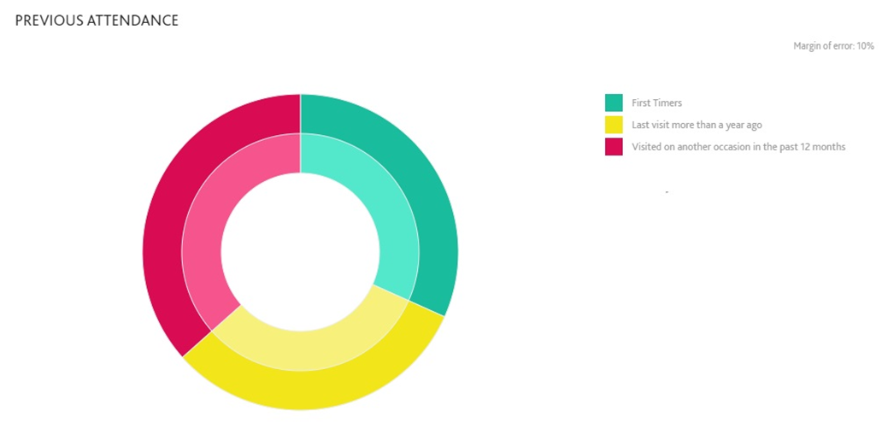

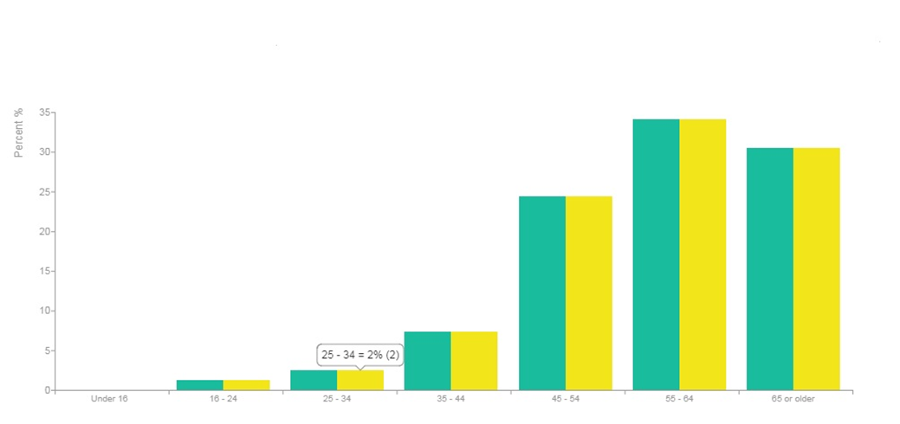
The average NDCWales audience in Wales and across the U.K are mostly middle aged, white collar, already highly engaged and is are confident arts attenders.
The Role of Tour and Projects Producer

The Tour and Projects Producer is responsible for the planning and delivery of National Dance Company Wales’ programme of performances, both on tour in the UK and internationally, and for its ambitious portfolio of projects in multiple formats in a variety of settings.

The Tour and Projects Producer works closely with the Chief Executive and Artistic Director on the planning of new creations, tours and partnerships with individuals and organisations of all kinds, within and beyond the cultural sector. The post-holder reports to the Chief Executive, and manages the Production Manager and their team, as well as a new post of Tour and Projects Officer (not yet recruited). They will work closely with the Marketing Director and Rehearsal Director in planning and delivering tours and projects.

NDCWales is looking for an experienced producer with a track record in the key areas of the post’s responsibilities.

Duties and responsibilities

The purpose of the post is to produce the performance programme of NDCWales, including:
- Touring and Projects strategy and Delivery
- Production Planning and Delivery
- Production Management
- Budgeting and financial management of creations and tours

Touring and Projects Strategy and Delivery
- Work closely with the Chief Executive and Artistic Director to shape the scope and nature of tours and new projects, balancing artistic, audience and financial factors
- Book both UK and international tours, negotiating terms with venues and promoters to maximise touring income
- Plan optimum travel and accommodation for tours, enabling the achievement of targets in the Company’s sustainability plan.

Production Planning and Delivery
- Schedule and oversee all production activity for creations and projects
- Ensure compliance with the terms of performance and associated licences
- Negotiate and contract freelance creatives including designers, directors, choreographers, and negotiate performing rights
- Manage the Company’s Sponsor Management System, applying for visas as required
- Ensure that performers, stage managers and technicians are contracted in line with Equity/ITC (or other appropriate) guidelines or in-house agreements
- Manage co-productions and collaborative projects, working on contracts with co-producers and of contracts with touring venues
- Bring a pioneering approach to the creation of international partnerships with theatres, festivals and strategic bodies
- Identify, develop and manage entrepreneurial opportunities such as touring or broadcasting the Company’s work
- Develop international markets and innovative partners for the company’s work
- Maintain and develop projects and links with partner organisations, nationally and internationally
- Schedule performances at the Dance House, both by the Company and visiting companies.

Production Management
- Manage the role of Production Manager, ensuring full alignment of tour and projects planning and production delivery
- Work closely with the Production Manager to enable the achievement of targets in the Company’s sustainability plan (e.g. approaches to haulage for both UK and international touring; sustainable models of site-specific performance)
- Clearing and licensing music in conjunction with the choreographer and sound designer

Budgeting and Financial Management
- Develop and monitor production budgets and to monitor income and expenditure against agreed budgets
- Delegate and monitor production budgets as appropriate for creations and rehearsals to Production Manager

General duties
- Act as a role model for all employees in terms of professional conduct, standards and policies.
- Deputise for the Chief Executive as required.
- Provide timely reports and information for the board.
- Undertake other duties reasonably expected by the Chief Executive to fulfil the role.

Person specification

Skills and experience

Essential
- Significant touring and project planning and delivery experience

- Outstanding attention to detail and accuracy

- Excellent administration and organisational skills, including IT skills

- Network of contacts within the UK and/or international touring circuit, and the norms of working with it

- An appetite for innovation in modes of presenting dance

- Experience of delivering projects with a variety of partners and stakeholders

- Experience of working with diverse teams and of supporting inclusion

- Solid financial capabilities and experience of working with finances and budgets

- A passion for dance

- A track record of effectively managing and pro-actively motivating staff

Desirable

- An understanding and appreciation of the dance touring sector

- Experience of managing/booking international touring arts events

- Working with standard theatre industry contracts for technical and performing staff

- Production management experience, and knowledge of technical aspects of theatre

- Appreciation of contemporary performance (particularly dance) Conversant with relevant health & safety and compliance legislation

Company Values

It is essential that all staff members demonstrate active promotion of the Company’s values. The six values are:

Curious and Pioneering

Inclusive and Versatile

Collaborative and Ambitious

Terms and conditions

The terms and conditions are indicative of a full-time appointment and would be negotiated accordingly for any joint or job-share appointment.

Salary: £30,000-£32,000, dependent on experience and qualifications

Pension: NDCWales currently contributes 3% of salary to a pension with Royal London, dependent on employee’s matching contribution

Contract: Permanent employment contract

Hours: Normal hours will be 37.5 hours per week, to be worked flexibly. TOIL is available for hours outside the ordinary.

Place of work: Mainly Cardiff, with extensive international and UK travel required

Holidays: 28 days per year plus 8 public holidays (3 of these days must be taken between Christmas and New Year)

We expect the post-holder to live locally.

Any offer of employment will be subject to the receipt of:
  - Satisfactory References
  - Evidence of right to work in the UK as defined by the Home Office
There will be a three-month probationary period, during which time regular monitoring meetings will be held with relevant representatives.
How to apply

Please apply by submitting the application form.

Please also indicate if you are an EU national or if you would require a visa.

Closing date for applications 9am, 1 October 2018. Candidates invited for interview will be notified by 5pm on 2 October.

Interviews will be held on 9 October.

Please e-mail Kelly Twydale at kelly@ndcwales.co.uk to request this pack in Welsh or in another format.

