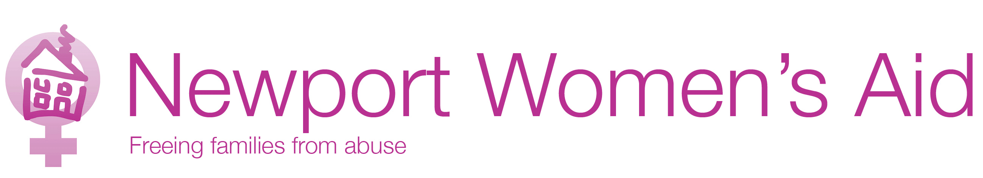

Equal Opportunities Statement

Newport Women’s Aid is committed to upholding the principles of equality and diversity in employment and in the provision of its service.

It is the policy of the organisation to take all reasonable steps to ensure that all current, former and potential employees, Service User’s and visitors receive equal treatment irrespective of their colour, gender, race, ethnic or national origin, sexual orientation, age, physical or mental disability, parental responsibility, marital status, religious beliefs or membership or not of a Trade Union.

This includes seeking to protect employees from harassment or bullying in the work place and/ or whilst on Newport Women’s Aid business, by investigating promptly any allegations and dealing with any employee who is found to be harassing or bullying a colleague using the organisation’s Harassment and Bullying Procedure.

In the provision of Newport Women’s Aid refuges and the employment of staff to provide all services, the organisation will seek to ensure equality of opportunity and treatment for all persons. No person or group of persons applying for refuge accommodation or employment or information / advice will be treated less favorably than any other person or group of persons because of their colour, race, ethnic or national origin, sexual orientation, age, physical or mental disability, parental responsibility, marital status, religious beliefs or membership or not of a Trade Union.

Underlying this commitment is a fundamental belief in the right of all employees and clients to be treated with dignity and respect.

We will operate this policy in line with relevant statutory requirements and under Welsh Women’s Aid Codes of Practice.
(Women only need apply – Where appropriate to the job role as per the Genuine Occupational Requirement Provisions of the Equality Act 2010 Part 1 Schedule 9)

