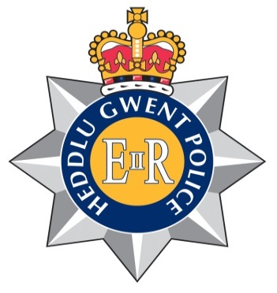
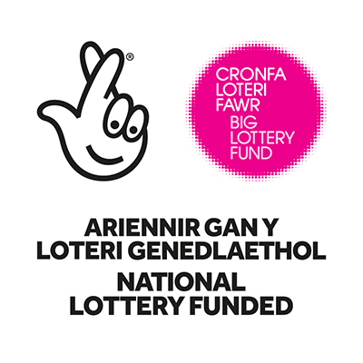
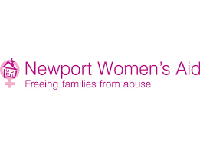

Job Description

Job title: Senior Crisis Intervention Worker

Reports to: Operations Manager

Salary Scale: £23,675

This post is subject to the Rehabilitation of Offender Act (Exceptions Order) 1975. It will be necessary for an enhanced DRS check to be made.

This post is subject to Police Vetting Level 3

To work in partnership with Gwent Police to provide an immediate response to victims of domestic abuse. The Senior Crisis Worker will be responsible for coordinating the development and delivery of the Crisis Intervention Service and provide leadership to staff in the Crisis Intervention Team.

The Senior Crisis Intervention Worker will be required to respond to domestic incidents reported to the police or incidents where Police Officers have attended and identified that there are domestic abuse risk factors.

The Senior Crisis Intervention workers will be required to complete a full assessment, including a DASH RIC. This information will then be used to complete a safety plan with the victim, including accessing emergency services such as refuge accommodation, SARC or health services. After an initial crisis response if provided the Senior Crisis Worker will work with the service user to develop a support plan to address any support needs identified and ensure that the appropriate support is put in place to reduce risk.

The Senior Crisis Intervention Worker will be responsible for actively taking part in the DACC, completing any actions and ensuring that information is shared between relevant organisations. NWA Crisis Team will ensure they have smooth channels of communication with Gwent Police and keep them informed of relevant information in line with our information sharing protocols.

The Crisis Intervention Team will act as the first point of contact for those affected by domestic abuse, there role includes encouraging engagement, reducing risk harm and enabling victims of domestic abuse to live free from abuse or fear of it.

Specific Responsibilities:

Access and Referral
- To act as the first point of contact with Newport Women’s Aid providing a crisis response to victims of domestic abuse in partnership and as directed by Gwent Police.

- To provide immediate advice, guidance, safety planning and support to those affected by Domestic Abuse

- To provide practical and emotional support to those who have been affected by DA in accordance with NWA’s ethos. Completing detailed assessments of those referred to the Crisis Intervention Project within the set time periods to identify support needs and how these can be addressed. Ensuring that all casework records are kept up to date.

- To work with Police staff to identify those suitable to be referred to the project and to feedback to the Officer and Domestic Abuse Unit the outcome of your assessment, including any recommendations or actions taken at time of crisis.

- Act as the access point to NWA’s services, to encourage engagement, reduce risk of harm and reduce the number of repeat victims of domestic abuse.

- To work with service users and other agencies involved to ensure that all aspects of needs assessment, risk assessment, safety planning and support planning are in place and reviewed regularly. Service users are to be involved in all aspects of support planning.

- To provide advice, guidance, coaching, mentoring and support to a caseload of those who have experienced domestic abuse via regular one to one meetings and group interventions as appropriate.

- To facilitate and maintain accurate records in relation to the Daily Domestic Abuse Conference Call (DACC)

- To advise service users on possible referral options and signpost those affected by domestic abuse to appropriate local agencies based upon identified needs and in consultation with service users

- To ensure that Service Users are aware of their rights to legal protection for themselves and their children, arranging for the provision of legal advice as required and accompany women to appointments if appropriate

- To enable Service Users to apply for / maintain/ maximise benefits and manage other financial issues. Support Service Users to access health services and other primary services required.

- Signpost and/or refer Service Users to appropriate internal and external services based on their needs.

- To ensure that any issues in relation to the safeguarding of children or vulnerable adults are responded to in line with NWA’s policies and procedures, including completing Child Protection, POVA and MARAC referrals.

- To recognise, respect and address the needs of Service Users who face particular barriers when seeking help to access the service, including those from different ethnic and cultural backgrounds, LGBT communities, disabled people, those with complex needs and other hard to reach groups.

- To maintain confidentiality and to ensure that professional boundaries are observed when working with Service Users, staff and external bodies

Information and Data Management
- To ensure that statistical information and monitoring systems are kept up to date

- To achieve and report on individual, weekly and monthly performance targets

- To ensure all service user files and documentation are kept in accordance with agreed confidentiality agreements

- To ensure that the views and experiences of those using NWA’s services, including external agencies are actively sought, recorded carefully and are used to inform the development of services

- To be an ambassador for NWA, working in partnership with other agencies to ensure an effective, coordinated community response is provided to those affected by DA

Education and Awareness Raising
- To ensure that staff within relevant agencies are aware of the Crisis Intervention Project and the work it undertakes as well as promoting the work of NWA

- To develop and maintain positive, collaborative working relationships with all staff, both within the Central Services Team and wider service, being committed as part of the team to providing a high level of support to people accessing NWA’s services

General
- To demonstrate and promote the organisation’s ethos of informed choice, and its vision and values.
- To proactively implement NWA’s policy for anti-discriminatory practice and equality of opportunity

- To represent the organisation at external meetings, public events, conferences and similar ensuring that Newport Women’s Aid reputation is protected and enhanced.

- To actively work in partnership with other agencies and organisations to achieve better outcomes for those affected by Domestic Abuse.

- To attend all meetings or training as requested by the Operations Manager or other member of the Management Team. To attend regular supervision sessions, participate in the annual appraisal system and attend training as required – which may involve travel outside of Newport.

- The post holder must at all times carry out duties and responsibilities with due regard to both NWA policies as well as the Police’s

- Any other reasonable duties as required

Management
- To provide leadership to the team in the delivery of day to day operations
- To develop and coordinate the crisis intervention service
- To oversee delivery to ensure delivery of high quality service
- To ensure the implementation of effective management process and procedures under your responsibility
- To ensure the paperwork, monitoring documents and databases are completed accurately
- To regularly review paperwork and electronic systems to ensure that they are streamlined to meet organisational needs
- To assist the operational manager with the reviewing of policies and procedures
- To support the operational manager with preparation for external audits and completing/submitting monitoring documents in line with funding obligations
- To work with the Operational Manager to identify sources of funding to develop and sustain services
- To support inductions of new staff
- To support monthly staff supervision and probationary assessments
- To assist in identifying staff training and development needs
- To escalate any concerns or complaints about staff or services to the Operational Manager and investigate as directed.

Equal Opportunities:
- To proactively implement Newport Women's Aid policies for anti-discriminatory practice and equality of opportunity.

Statement of Flexibility:
- It may be necessary, following consultation, to amend the job description in light of experience and changing circumstances.

- The post holder will be required to work evenings and weekends as part of a rota system. This will include a range of shifts with priority cover being given to 1pm until 9pm 7 days a week as this has been identified by the police as a key time for crisis response.

- The post holder is required to participate in the organisation’s 24 hour on-call rotas.

Location: The role be responsive and include being based at Police Headquarters. The post will include working in the community and responding to crisis assessments within members of publics homes. You will be required to work across Gwent as needed.

Person Specification: (the skills, experience and qualities which are expected from Crisis Intervention Workers)

Essential Characteristics

Education,
- Level 3 qualification or equivalent experience in a related discipline

Experience, Knowledge, Skills and abilities
- Experience of working within Domestic Abuse or Sexual Violence Services
- Experience of working with individuals and families who have differing social and emotional needs
- Experience of providing information, advice and guidance to service users who are in a crisis situation
- Experience of developing and engaging service users in individual support planning or similar
- Experience of undertaking service user centred risk assessment and risk management
- An understanding of the issues around service user participation and how to engage them in productive and meaningful dialogue
- Experience of working in partnership with and developing relationships with other agencies, especially the Police
- Experience of using IT/ Computer based systems of a daily basis
- An understanding/experience of domestic abuse and the services available to provide support
- A clear understanding of boundaries within support work.
- Ability to liaise, network and advocate.
- Experience of managing challenging behaviour and conflict
- Sound knowledge around the importance of clear assessments within a timely fashion
- Ability to undertake needs assessments and construct realistic individual support plans
- Ability to assess complex needs and identifying priorities
- Ability to provide meaningful practical and emotional support
- Excellent written and verbal communication skills including the ability to maintain clear and concise client records
- Ability to work effectively on own initiative, with minimal direct supervision as well as working as part of a team
- Excellent organisation skills and ability to prioritise workload
- Administrative and file management skills and ability
- Comprehensive understanding of anti-discriminatory practice
- Knowledge and understanding of the principles of confidentiality
- Excellent IT skills, including Excel and PowerPoint
- Ability to undertake risk assessments with regards to yourself, co-workers and service users
Personal attributes
- Commitment to the aims and principles of NWA
- Resilient
- Ability to work evenings and weekends as part of a rota system over a 7 day period
- Reliable
- Empathetic
- Positive outlook
- Enhanced CRB Clearance
- Full valid driving licence

Desirable
- Line Management experience within Domestic Abuse or Sexual Violence Services
- IDVA trained qualification
- Experience of working in partnership with statutory services such as the Police
- Experience working within a multi-agency setting to develop new projects
- Project Management Ability
- Ability to speak Welsh or other language.

For further information and an application pack please call us on 01633 840258 or e-mail office@nptwomensaid.co.uk.
Closing Date for both posts Monday 2nd July 2018

Due to the nature of the roles they are only open to female applicants (Exempt under the Equality Act 2010 pursuant to Schedule 9, Part 1)

