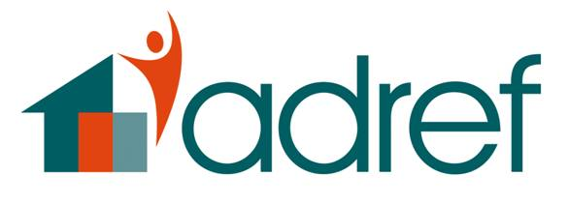JOB DESCRIPTION

POST: Homeless Complex Needs Worker

HOURS: Full-time Post: 35 hours per week. Initially until March 31st 2019 with
the possibility of continuation of funding.

GRADE: £24,174

RESPONSIBLE TO: Mill Street Hostel Manager

BASED: Mill Street Hostel, Pontypridd but also working
at The Grange, Pontypridd.

Main Responsibilities

- To work in an innovative and creative way in order to engage clients within the Adref hostels who have chaotic and complex needs.

- To work in partnership with other professionals including substance misuse, alcohol and mental health agencies.

- To work with other professionals in order to identify the different types of support available for clients individual needs and to empower clients by identifying their choices.

- To act as a vital link between the client and services supporting them to appointments if needed.

- To work closely with hostel staff in order to provide the best outcome for clients.

- To provide one to one support and / or group support as needed.

Obligations

- To work to further the overall vision, mission, values and operational principles of Adref Ltd.

- To work within Adref’s Equal Opportunities Policy at all times.

- To provide a client focussed service.

- To work in a manner that lessens dependency and strives to empower clients.

- To comply with Adref`s financial procedures.

Other Duties

- Ensure that the projects administrative paperwork is completed and that databases are maintained.

- Ensure that all paperwork is filed correctly and that all records are accessible for the Manager to inspect.

- Attend partnership meetings under the direction of the Manager.

- Attend project specific team meetings.

- Attend regular supervision with the Manager.

- Attend training/conferences in agreement with the Manager.

- Contribute to the development of the project and the organisation, and the review of policy and procedure.

- Work with the Hostel Manager, hostel staff and partners in promoting the service within Rhondda Cynon Taf.

- Any other duties commensurate with the post.

Other Adref Schemes
Adref has a policy of generic working. This means that you may be required to lend your skills, knowledge or experience for the benefit of another scheme.

