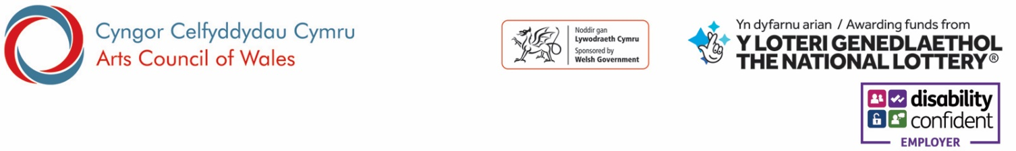
Equal Opportunities Monitoring

The Arts Council of Wales aims to be an equal opportunity organisation, and selects candidates solely on merit irrespective of race, age, colour, ethnic or national origins, marital status, gender, gender identity, sexual orientation, disability, religion or beliefs.
In order to monitor the effectiveness of our Equal Opportunities policy, we ask all applicants to provide the following information:

Post applied for

Gender
What is your gender?
(Please specify)

Age
Under 20 | 20-29 | 30-39 | 40-49 | 50-59 | Over 60
Prefer not to say

Relationship Status
Married/Civil Partnership | Divorced | Single | Widowed | Other
Prefer not to say

Sexual Orientation
Bisexual | Gay/Lesbian | Heterosexual/Straight
Other (Please specify)
Prefer not to say

Religion/Belief
Buddhist | Christian | Hindu | Jewish | Muslim | Sikh | No Religion
Other (Please specify)
Prefer not to say

National Identity/Ethnic Origin

How would you describe your national identity?
Welsh | English | Scottish | Northern Irish | British
Other (Please specify)

What is your ethnic group?

A. White
Welsh / English / Scottish / Northern Irish / British
Irish
Gypsy or Irish Traveller
Any other White background (Please specify)

B. Mixed / multiple ethnic groups
White and Black Caribbean
White and Black African
White and Asian
Any other Mixed / multiple ethnic background (Please specify)

C. Asian / Asian British
Indian
Pakistani
Bangladeshi
Chinese
Any other Asian background (Please specify)

D. Black / African / Caribbean / Black British
African
Caribbean
Any other Black / African / Caribbean background (Please specify)

E. Other ethnic group
Arab
Any other ethnic group (Please specify)

Disability

The Equality Act 2010 defines a disabled person as a person who has a disability. A person has a disability if he or she has a physical or mental impairment which has a substantial and long term adverse effect on (his or her) ability to carry out normal day to day activities.

Do you consider yourself to be a disabled person?

No Yes

If yes, is your disability related to any of the following:

Learning Disability (e.g. dyslexia, dyspraxia)
Long term illness/health condition (e.g. asthma, diabetes, epilepsy, Multiple Sclerosis)
Sensory Impairment (e.g. Blind, Deaf, Glaucoma, hearing impairment, visual impairment)
Mental Health Condition (e.g. anorexia, depression, schizophrenia)
Physical Impairment (e.g. amputation, wheelchair user, manual dexterity issues)
Cognitive Impairment (e.g. Autism, Aspergers Syndrome, head injury)
Other (Please specify if you wish)

Language preference

In which language would you like to be communicated with? We welcome correspondence in Welsh as well as English and corresponding in either language will not lead to any delay.
(Please note: interview questions and assessments may be held in Welsh and English where the ability to speak Welsh is essential for a role)

Welsh English

Data Protection: Information from this application form may be processed for purposes registered by the employer under the Data Protection Act 1998. Individuals have, on written request (and on payment of a fee) the right of access to personal data held about them.

I hereby give my consent to the Arts Council of Wales processing the data supplied in this form for the purpose of recruitment and selection.

Applicants Signature Date:

